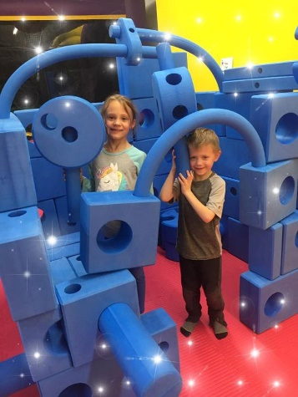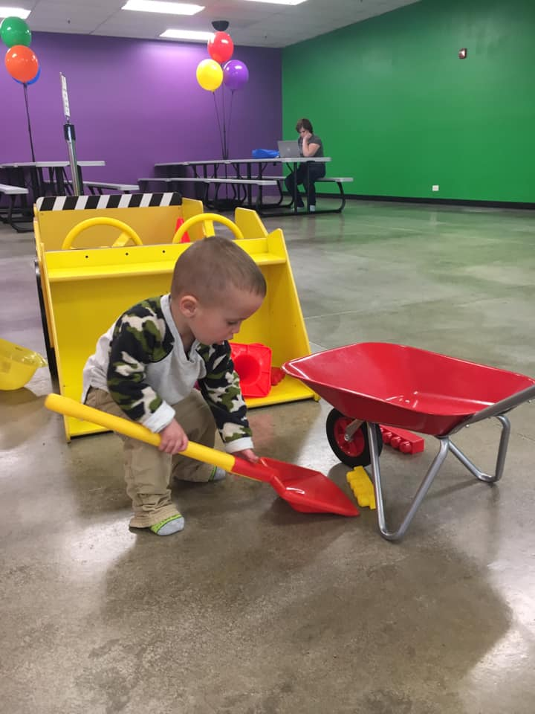

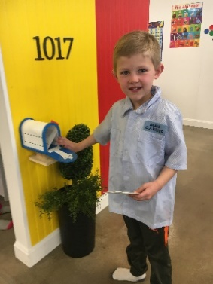

South Denver Metro’s ONLY

Intentional Play Center

Dedicated to the

Physical, Intellectual, Social and Emotional Development of Children 0-6



Field Trip – So Much Fun!

[ Date ], 2025 - [Time leaving school – Time returning]

7562 S. University Blvd. #GG Centennial, Colorado 80122, Waiver Needed – Socks Only

kidswonder.net #303-835-0709 @ilovekidswonder





South Denver Metro’s ONLY

Intentional Play Center

Dedicated to the

Physical, Intellectual, Social and Emotional Development of Children 0-6



Field Trip – So Much Fun!

[ Date ], 2025 - [Time leaving school – Time returning]

7562 S. University Blvd. #GG Centennial, Colorado 80122, Waiver Needed – Socks Only

kidswonder.net #303-835-0709 @ilovekidswonder